June 2020

Clean Slate

Volunteers Application Pack
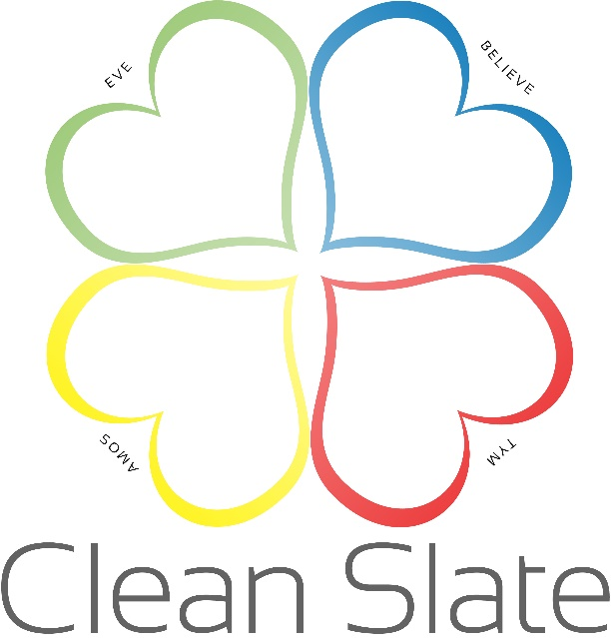
A Helping Hand To Move On

Volunteer Application Form

Any information given on this form is confidential and covered by the EU General Data Protection Regulation (GDPR) 2018
Post:
Date enquired:
Where did you hear about volunteering for Clean Slate?

CONTACT DETAILS:
First Name: | Surname:
Email address:
Address:  Postcode: | Contact number:

Volunteers are an integral part of Clean Slate, working in all areas of the organisation. Their role is highly valued and are recognised as equals with a unique contribution to make, working alongside and in close co-operation with the staff team.
Why do you want to volunteer at Clean Slate and what would you like to gain from your volunteering experience?

Please fill in if you are a TRAINEE/STUDENT Counsellor or Psychotherapist.
Which institution are you training at?
What type of counselling / psychotherapy are you training in?
What year/level of training are you in?
Do you have professional indemnity insurance?

Please fill in if you are a QUALIFIED Counsellor or Psychotherapist.
What year did you complete the counselling / psychotherapy training?
What type of counselling / psychotherapy are you trained in and where did you study?
Are you accredited with BACP (or relevant body) and do you have professional indemnity insurance?

In what areas of Clean Slate would you like to volunteer? Please tick where appropriate.
One to One client support
Young People’s projects
Group therapy
Support groups
Helpline
Administration
Publicity & Marketing - Leaflets, Newsletters,
Social Media – Website, Facebook, Instagram
Fundraising – Funding, Events, donations
Volunteer Development/HR
Research
Other (please comment)

Professional Qualifications. Please include any relevant certificates with your application form.
Training/short courses attended relevant to this post.

Current (Or Most Recent) Employment
Job or role title:
Name of Organisation or Company:
Date started and date left:
Please provide a summary of main duties & responsibilities:

Previous employment history (approx. 5 lines)

What previous experience and skills, personal interests and achievements have you gained that will help you in your voluntary work at Clean Slate?

Declaration of Criminal Convictions. When applying for a post in Clean Slate, all criminal convictions must be disclosed. ‘Spent’ convictions must also be disclosed.
(Rehabilitation of Offenders (Exemption Order 1975) Checks will be made with the Police.
Have you ever been convicted of, or cautioned for, a criminal offence? Please list
You will not necessarily be excluded from being interviewed by answering yes.

Do you have any support needs? If yes, please specify.

Availability
Approximately how much time would you like to give to Clean Slate?
Please indicate regular days or times
For what length of time do you hope to volunteer with Clean Slate?

References
Please provide us with the names and addresses of two people who have known you for at least two years and are not members of your family.
Referee One
Full Name:
Address:
In what capacity do you know the referee?
Email address:
Referee Two
Full Name:
Address:
In what capacity do you know the referee?
Email address:
Details Of Criminal Convictions – Do you have any unspent criminal convictions? If yes, please provide details:

I certify that the information provided is complete and correct. I understand that canvassing or failure to provide complete and correct information may result in the withdrawal of an offer of volunteering.
Signed: Dated:

Please complete and return this form to: email to: office@cleanslate.org.uk

eQUAL OPPORTUNITIES MONITORING
We believe that there should be no discrimination (direct or indirect) in relation to the recruitment or training of our volunteers on grounds of disability, marital status, ethnic origin, religion, sex, sexuality or age.
This policy is in accordance with the full provisions of the Sex Discrimination Act 1975, Disability Discrimination Act 1995, Race Relation Amendment Act 2000 and the Employment Equality (Age) Regulations 2006.
To ensure that the Equal Opportunity Policy is effective, detailed monitoring of applications is carried out. This necessitates collecting information regarding your disability, ethnic origin and sex etc. Your co-operation is appreciated.
This information is used solely for monitoring purposes. It will be treated as confidential and this sheet will be detached from your application form on its receipt and before the shortlisting of candidates take place.
The information on this form is subsequently stored on computer and is subject to the provisions of the Data Protection Act. No identifying information will be retained with this sheet.

Gender: Male Female
Age:
Date of Birth:
Marital Status:
Number of Dependent Children:
How would you describe your ethnic origin?

Disability We are taking positive steps to encourage the recruitment of volunteers with disabilities.
Do you consider yourself to have a disability you would like to tell us about? Yes No
Do you require any assistance with the interview process? Yes No
If Yes, please give details:
If you require any assistance with your application,
please contact us

